Template Final Exam

|  |  |  |
| --- | --- | --- |
| # | Full Name | Group |
| 1 | Maralbayev Adil’ | CS-2113 |
| 2 | Omar Gabdu-Samad | CS-2113 |
| 3 | Rakhym Erasyl | CS-2113 |
| 4 | Tulegen Miras | CS-2119 |
| 5 | Kayrolla Aydarkhan | CS-2119 |

|  |
| --- |
| Link to the repository: |

Step-by-step task completion:

Task 1:

Screenshots of the code compilation result:

Adding new user:

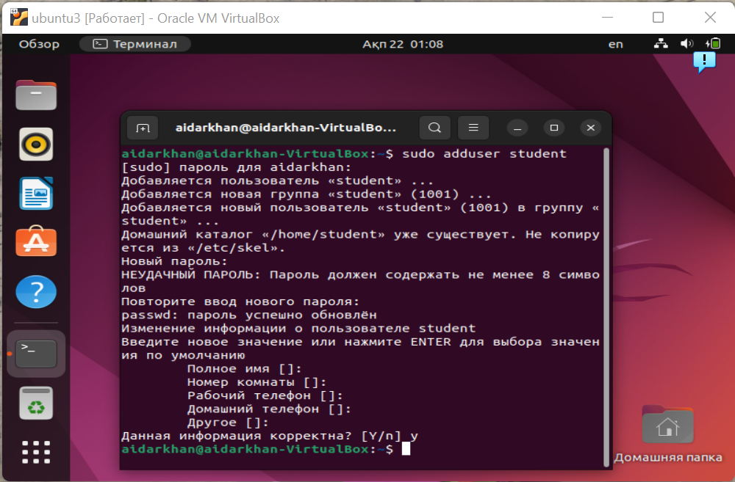

Adding to this user sudo root permissions

And using sudo su student – to login as user:

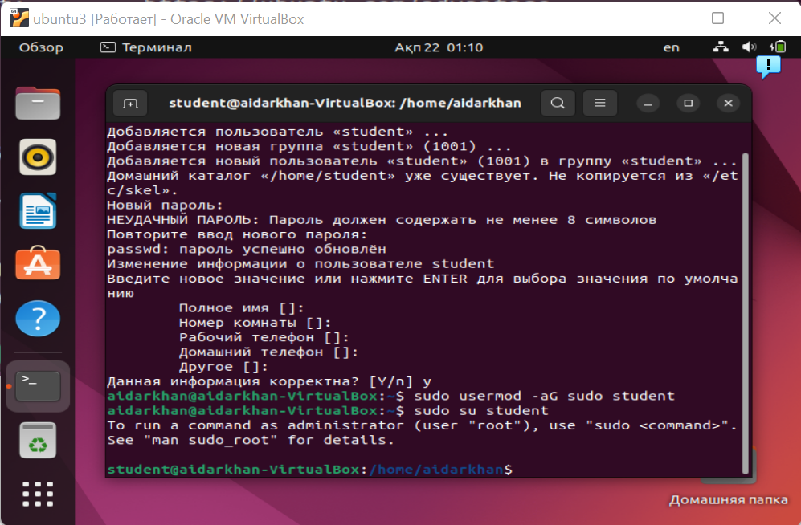

sudo login student- same as sudo su student.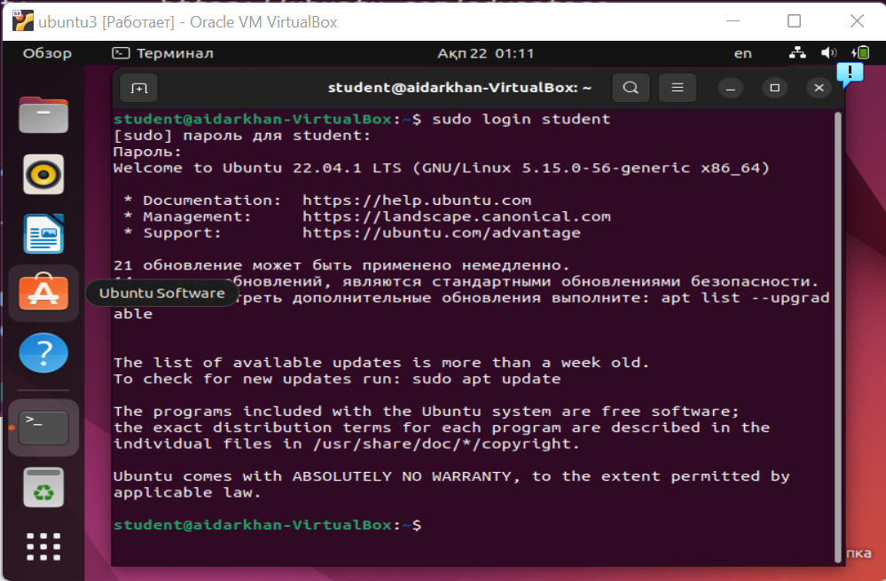

Using whoami for checking what user we are

And logout – logging out from user “student” to main user “Aidarkhan”

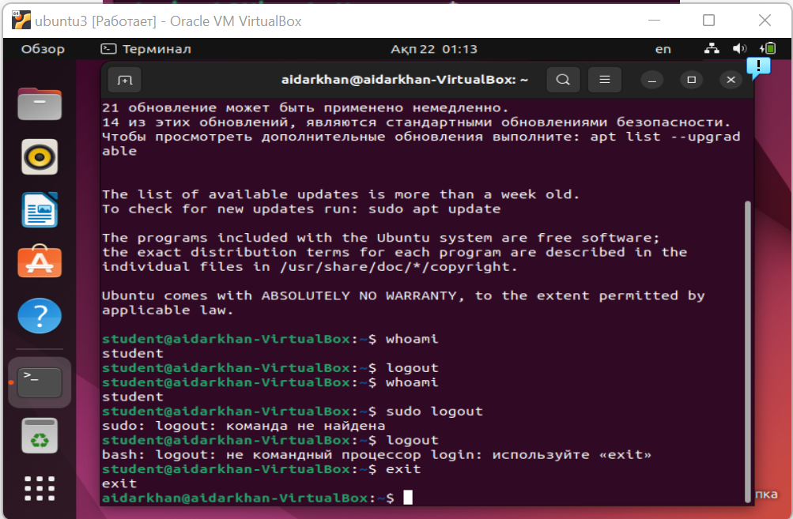

Task 2:

Screenshots of the code compilation result:

Installing network-manager with dhcpcd packets.

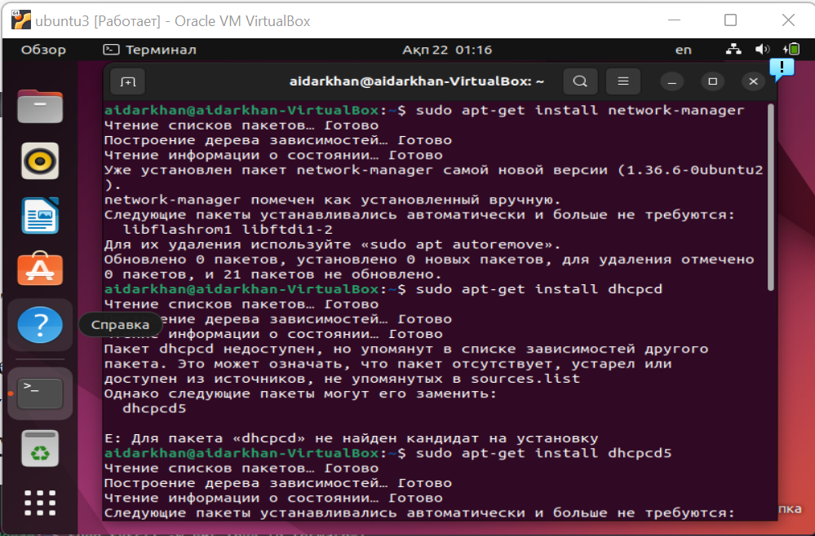

Checking connection by pinging web services

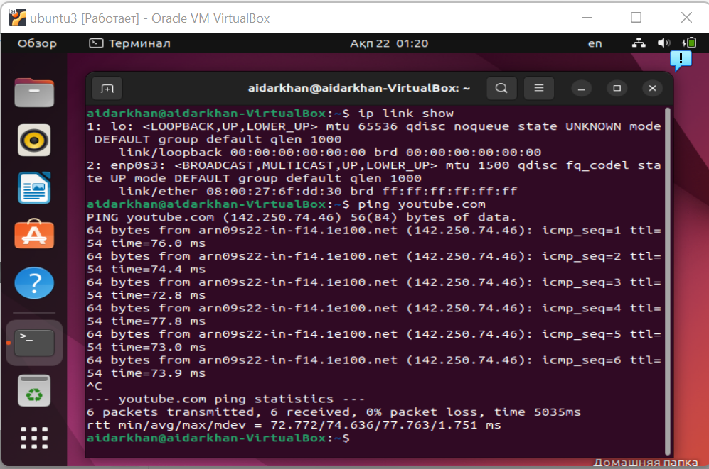

Checking out NAT iptables

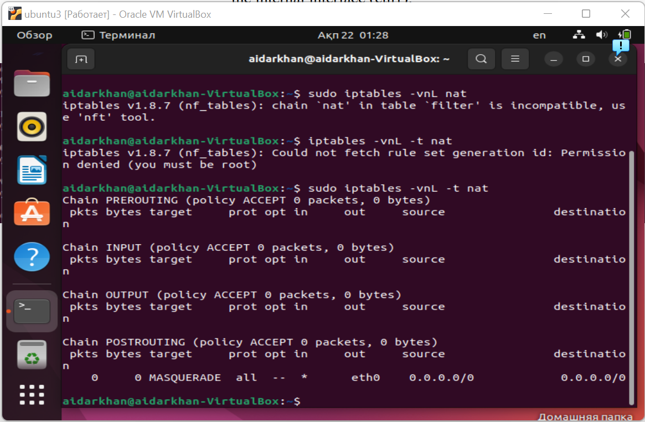

Task 3:

Screenshots of the code compilation result:

Connecting proxy via berp suit

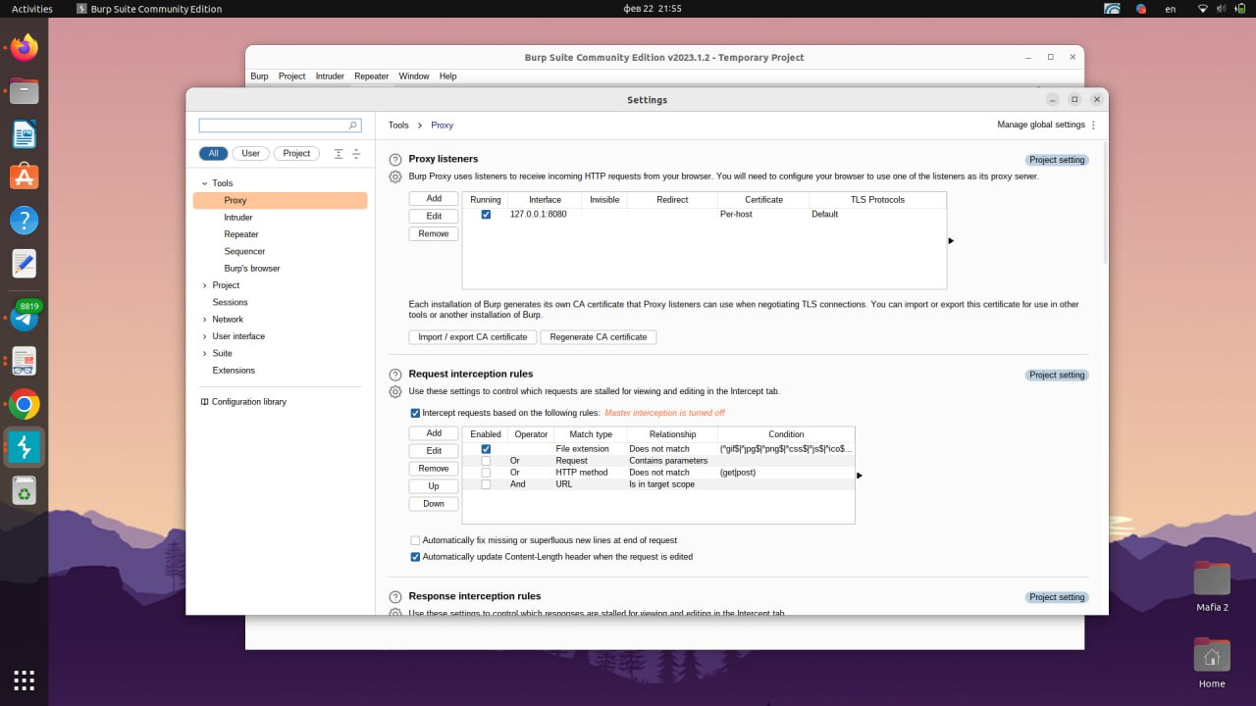

https is not working without certificate

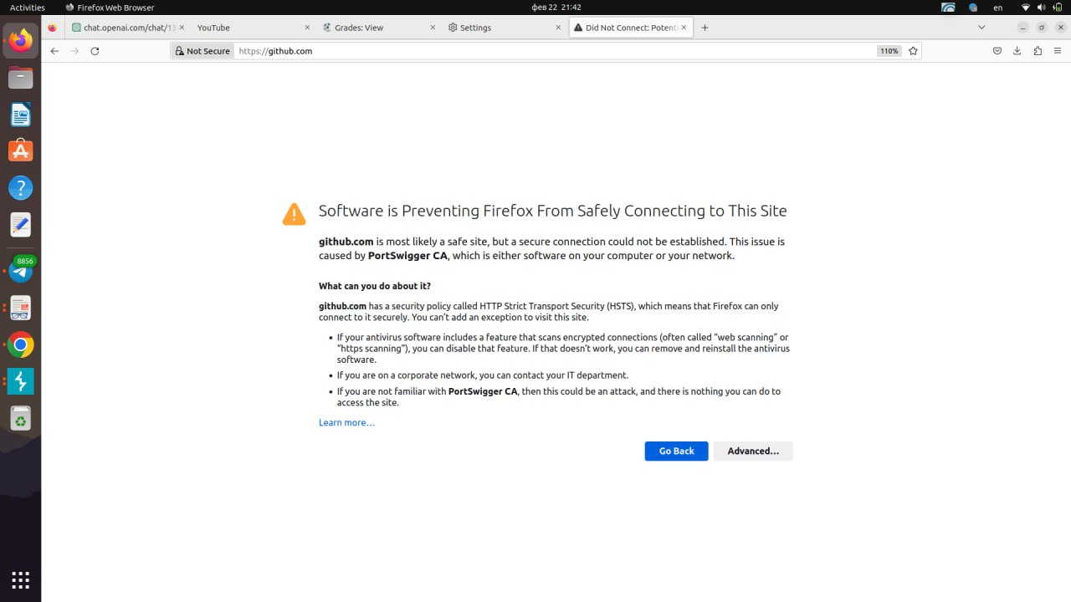

Importing the certificate:

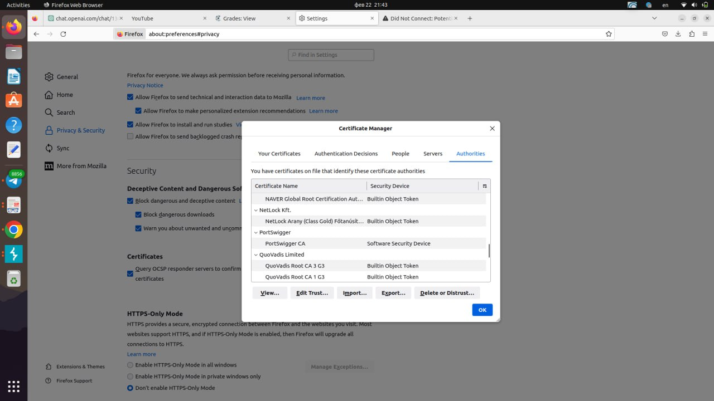

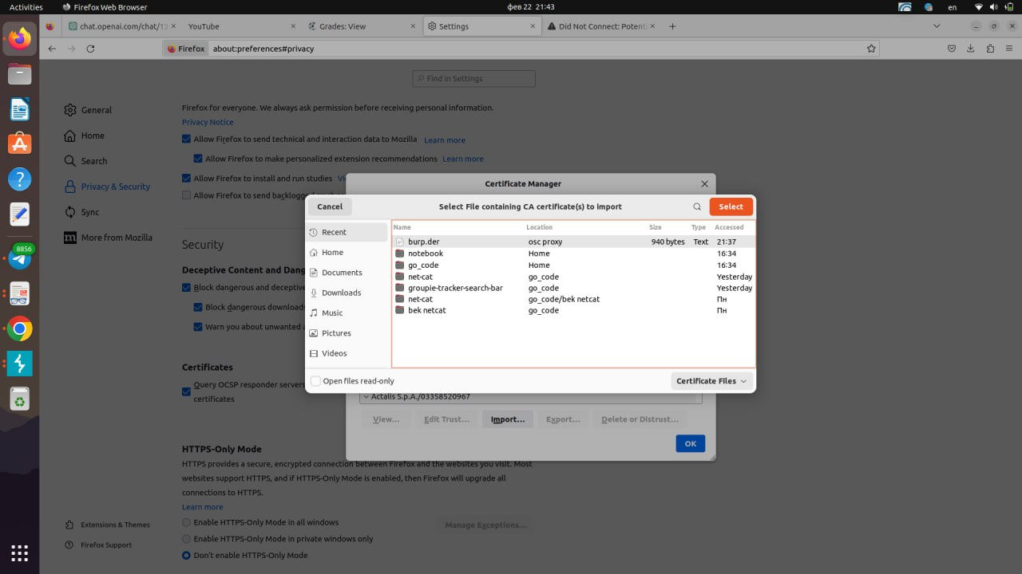

Here we see can that https connection is working:

